Template for Evidence(s)
UI GreenMetric Questionnaire

University : ...
Country : ...
Web Address : …

[6] Education and Research (ED)
SAMPLE
[6.3] Total number of study program related to sustainability offered

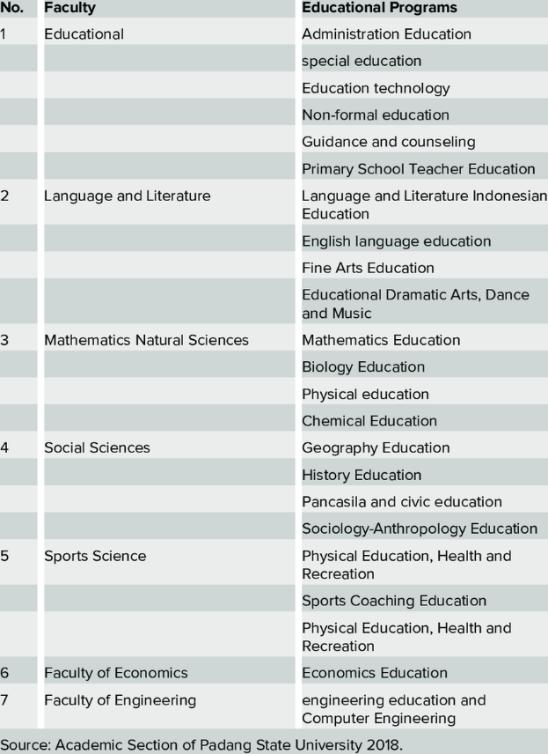
Number of study program related to sustainability offered

Description:
(Please describe Total number of study program related to sustainability offered on your campus. The following is an example of the description. You can describe more related items if needed.)

Above is a list of the study program that have had changes approved through Curriculum Refresh programme which aims to embed sustainability into all course and module content offered by the University.

Additional evidence link (i.e., for videos, more images, or other files that are not included in this file):

